United States Department of the Interior
National Park Service

National Register of Historic Places
Registration Form

This form is for use in nominating or requesting determinations for individual properties and districts. See instructions in National Register Bulletin, How to Complete the National Register of Historic Places Registration Form. If any item does not apply to the property being documented, enter "N/A" for "not applicable." For functions, architectural classification, materials, and areas of significance, enter only categories and subcategories from the instructions. Place additional certification comments, entries, and narrative items on continuation sheets (NPS Form 10-900a).

1. Name of Property
Historic name | Macomb, Alexander, School
Other names/site number |  | Macomb, Alexander, Elementary School
2. Location
street & number |  |  |  | 12021 Evanston St. |  |  |  |  |  |  |  |  |  |  | not for publication
city or town |  |  | Detroit |  |  |  |  |  |  |  |  |  |  |  | vicinity
State | Michigan |  |  |  | code | MI | county | Wayne | code | 163 | zip code |  |  |  |  | 48203
3. State/Federal Agency Certification

As the designated authority under the National Historic Preservation Act, as amended,
I hereby certify that this X nomination _ request for determination of eligibility meets the documentation standards for registering properties in the National Register of Historic Places and meets the procedural and professional requirements set forth in 36 CFR Part 60.
In my opinion, the property X meets _ does not meet the National Register Criteria. I recommend that this property be considered significant at the following level(s) of significance:
national statewide X local

____________________________________
Signature of certifying official Date

Michigan State Historic Preservation Officer ________________ Michigan State Historic Preservation Office
Title State or Federal agency and bureau
In my opinion, the property meets does not meet the National Register criteria.

____________________________________
Signature of commenting official Date

___________________ _________
Title State or Federal agency and bureau

4. National Park Service Certification
I, hereby, certify that this property is: Signature of the Keeper Date of Action

entered in the National Register _________________________________________________________________

determined eligible for the National Register _________________________________________________________________

determined not eligible for the National Register ___________________

removed from the National Register _________

other (explain:) _________________________________________________________________

5. Classification

Ownership of Property  (Check as many boxes as apply) |  |  | Category of Property  (Check only one box) |  |  | Number of Resources within Property  (Do not include previously listed resources in the count.)
 |  |  |  |  |  | Contributing | Noncontributing
 |  | private |  | X | building(s) | 1 | 4 | buildings
 | X | public - Local |  |  | district |  |  | sites
 |  | public - State |  |  | site |  |  | structures
 |  | public - Federal |  |  | structure |  |  | Objects
 |  | private |  |  | building(s) |  |  | buildings
 |  |  |  |  | object | 1 | 4 | Total

Name of related multiple property listing  (Enter "N/A" if property is not part of a multiple property listing) |  | Number of contributing resources previously listed in the National Register

Public Schools of Detroit

6. Function or Use
Historic Functions  (Enter categories from instructions) |  | Current Functions  (Enter categories from instructions)
EDUCATION/school |  | EDUCATION/school

7. Description
Architectural Classification  (Enter categories from instructions) |  | Materials  (Enter categories from instructions)
Tudor Revival |  | foundation: |  | Concrete
 |  | walls: | Brick
 |  | roof: | Asphalt
 |  | other: | stone

Narrative Description
(Describe the historic and current physical appearance of the property. Explain contributing and noncontributing resources if necessary. Begin with a summary paragraph that briefly describes the general characteristics of the property, such as its location, setting, size, and significant features.)

Summary Paragraph

Alexander Macomb School occupies a full city block in a residential neighborhood on Detroit’s east side, about four miles northeast of downtown. The site is bounded by Harrell Street, Evanston Street, Barrett Street, and Camden Street.
The school building itself is located in the southeast quarter of the site and its front façade faces east onto Harrell Street. Its south-facing, Evanston Avenue façade is also prominent. It is a two story, flat-roofed brick building with castle-like Tudor Revival details such as crenellated towers and parapets. The building appears to be in good condition and retains a high degree of architectural integrity. Four temporary classroom units (noncontributing) are located to the north of the original building, with the western half of the site devoted to a parking lot and playground.

________________________________________________________________________________________________________________________
Narrative Description

Macomb School occupies an L-shaped footprint, with a rectangular core block and an ell housing a gymnasium extending to the rear along Evanston Avenue. The building’s Flemish-bond brickwork is of mottled shades ranging from dark brown to bright orange.

The building’s entrance portal, facing east on Harrell, is sheltered by a projecting shed roof, originally clad in slate but replaced with asphalt shingles, and flanked by two squat, gable-topped piers, decorated by pairs of slender, engaged classical columns. These flanking piers are edged by stone quoins. Near the top of each pier reads “A.D. 1928” in raised bronze letters. Above the building’s entrance are the words “ALEXANDER MACOMB SCHOOL” in similar bronze lettering.

The building’s symmetrical façade is divided into three sections by a pair of three-faceted, engaged “towers” with crenellated parapets. The building’s entrance is flanked by two bays of windows on each side, which are in turn flanked by the pair of engaged towers. Each tower features prominent stone quoins and narrow windows resembling balistraria. In addition to the crenellations atop each tower, a parapet wall that tops the building between the towers is also crenellated, and rests on a low, cornice-like detail consisting of a row of alternating squares of brick and stone. Each end of the façade is anchored by a section containing two additional bays of windows. These are topped by a shorter parapet wall, containing a course of alternating squares of stone and brick beneath the coping, suggesting crenellation, that also continues around to the side elevations.

The building’s southern and northern elevations each contain a two-story, side entrance projection topped by a gabled roof. Above its doorway, lighting the upper story, are a series of four narrow, formerly leaded, glass windows. This bank of windows is emphasized by horizontal and vertical courses of contrasting brickwork, an allusion to Tudor-style decorative half-timbering. The doorway itself is recessed within a Tudor-arched, stone surround, with the name of the school in bronze letters on a stone panel. To the east of the south side entrance is a solid brick wall; to its west are windows similar to that of the front façade and beyond them, the tall, one-story gymnasium. Centered on the rear of the building is a five-sided bay to the kindergarten room that, on the interior, is lined with a window seat at its perimeter. The interior also originally had a structure centered in the bay that contained a water fountain, aquarium and sand bin, according to the building plans.

8. Statement of Significance

Applicable National Register Criteria
(Mark "x" in one or more boxes for the criteria qualifying the property for National Register listing)
 | A |  | Property is associated with events that have made a significant contribution to the broad patterns of our history.
 | B |  | Property is associated with the lives of persons significant in our past.
X | C |  | Property embodies the distinctive characteristics  of a type, period, or method of construction or represents the work of a master, or possesses high artistic values, or represents a significant  and distinguishable entity whose components lack individual distinction.
 | D |  | Property has yielded, or is likely to yield, information important in prehistory or history.
Criteria Considerations
(Mark "x" in all the boxes that apply)
Property is:
 |  | A | owned by a religious institution or used for religious purposes.
 |  | B | removed from its original location.
 |  | C | a birthplace or grave.
 |  | D | a cemetery.
 |  | E | a reconstructed building, object, or structure.
 |  | F | a commemorative property.
 |  | G | less than 50 years old or achieving significance
 |  |  | within the past 50 years.
Areas of Significance
(Enter categories from instructions)
Architecture
Period of Significance
1928
Significant Dates
1928
Significant Person
N/A
Cultural Affiliation

N/A
Architect/Builder
N. C. Sorensen

Period of Significance (justification)

The Period of Significance includes the building’s date of construction.

Criteria Considerations (explanation, if necessary)

Statement of Significance Summary Paragraph (provide a summary paragraph that includes level of significance and applicable criteria)

Alexander Macomb School is locally significant under National Register Criterion C for its unique, castle-like architecture. While its Tudor Revival predecessors, from McKinstry School (1905) to Newberry School (1928), feature more domestically-inspired details such as pitched roofs and wooden elements, Macomb School stands out with its flat roof, crenellated towers, and turrets.

________________________________________________________________________________________________________________________
Narrative Statement of Significance (provide at least one paragraph for each area of significance)

Macomb school opened February 18, 1929, replacing Trombly School, a one or two room brick building located at the intersection of Conner and Wade Streets. It was named after Alexander Macomb (1782-1841), a Detroit native who served in the War of 1812 and later as Commanding General of the United States Army. Macomb spent much of his career as an officer in the Army Corps of Engineers, where he was responsible for the erection of numerous coastal and frontier fortifications including those at Fort Gratiot, Michigan. He played a role in the United States victory at the Battle of Plattsburgh on Lake Champlain, near the close of the War of 1812. He eventually rose to become the army’s Chief Engineer, from which position President John Quincy Adams, in 1928, promoted him to Commanding General, the highest rank in the United States Army.

In the 1930s, enrollment at Macomb School approached 800 students, and the school was organized into a sixteen-section platoon with one self-contained classroom. By 1955 the student population had declined to 640. In the following years, enrollment declined further, to 533 in 1957, as construction of the Edsel Ford Freeway resulted in the razing of homes and the displacement of residents. In 1958 an “Americanization” class was begun at the school, in response to a high immigrant population in the area. Due to the neighborhood’s stable, and then gradually declining, population, this building was never expanded or significantly altered since its construction.

Macomb School is one of nine extant school building designs by the Detroit architectural firm N. C. Sorensen & Company. N. Chester Sorensen worked with the firm of Malcomson and Higginbotham in the early to mid-1920s. For two decades, Sorenson’s practice designed Detroit school buildings in a variety of architectural styles, beginning in 1926 with the Spanish Colonial Revival Higginbotham School, and ending with the International Style Ann Arbor Trail School in 1946.

________________________________________________________________________________________________________________________
Developmental history/additional historic context information (if appropriate)

9. Major Bibliographical References

Bibliography (Cite the books, articles, and other sources used in preparing this form on one or more continuation sheets)

Previous documentation on file (NPS): |  | Primary location of additional data:
 | preliminary determination of individual listing (36 CFR 67 has been |  |  | State Historic Preservation Office
 | requested |  |  | Other State agency
 | previously listed in the National Register |  |  | Federal agency
 | previously determined eligible by the National Register |  |  | Local government
 | designated a National Historic Landmark |  |  | University
 | recorded by Historic American Buildings Survey #____________ |  |  | Other
 | recorded by Historic American Engineering Record # ____________ |  | Name of repository:

Historic Resources Survey Number (if assigned): _____________________________________________________________________
10. Geographical Data

Acreage of Property | 2.14
(Do not include previously listed resource acreage)

UTM References
(Place additional UTM references on a continuation sheet)

1 | 17 |  | 336711 |  | 4696113 |  |  | 3
 | Zone |  | Easting |  | Northing |  |  |  | Zone |  | Easting |  | Northing
2 |  |  |  |  |  |  |  | 4
 | Zone |  | Easting |  | Northing |  |  |  | Zone |  | Easting |  | Northing

Verbal Boundary Description (describe the boundaries of the property)

N EVANSTON 63 THRU 61 AND VAC ALLEY ADJ SAID LOTS BARRETT & WALSHS HARPER AVE SUB NO 1 L41 P8 PLATS, WCR 21/600 ALL THAT PT OF 9 LYG N OF & ADJ EVANSTON AVE S OF & ADJ CAMDEN AVE AS OP SUB OF P C 10 L1 P98 PLATS, W C R 21/481

Boundary Justification (explain why the boundaries were selected)

The boundaries described above include the entire parcel historically associated with Macomb School.

11. Form Prepared By
name/title | Timothy Boscarino
organization |  |  | City of Detroit Historic Designation Advisory Board |  | date | March 25, 2009
street & number |  |  |  | CAYMC, 2 Woodward Avenue, Suite 204 | telephone |  |  | (313) 224-3487
city or town |  | Detroit |  |  | state |  | MI |  | zip code | 48226
e-mail |  | cc-historic@detroitmi.gov

Additional Documentation
Submit the following items with the completed form:

- Maps: A USGS map (7.5 or 15 minute series) indicating the property's location.

A Sketch map for historic districts and properties having large acreage or numerous resources. Key all photographs to this map.

- Continuation Sheets

- Additional items: (Check with the SHPO or FPO for any additional items)

Photographs:
Submit clear and descriptive black and white photographs. The size of each image must be 1600x1200 pixels at 300 ppi (pixels per inch) or larger. Key all photographs to the sketch map.

See continuation sheet.

Paperwork Reduction Act Statement: This information is being collected for applications to the National Register of Historic Places to nominate properties for listing or determine eligibility for listing, to list properties, and to amend existing listings. Response to this request is required to obtain a benefit in accordance with the National Historic Preservation Act, as amended (16 U.S.C.460 et seq.).
Estimated Burden Statement: Public reporting burden for this form is estimated to average 18 hours per response including time for reviewing instructions, gathering and maintaining data, and completing and reviewing the form. Direct comments regarding this burden estimate or any aspect of this form to the Chief, Administrative Services Division, National Park Service, PO Box 37127, Washington, DC 20013-7127; and the Office of Management and Budget, Paperwork Reductions Project (1024-0018), Washington, DC 20503.

United States Department of the Interior
National Park Service

National Register of Historic Places Continuation Sheet

Section number 9 | Page 1
_________________________________________________________________________________________________________________________

Bibliography

Detroit, City of, Board of Education. Histories of the Public Schools of Detroit. Detroit: Board of Education, 1967.

City of Detroit, Building Safety & Engineering, Blueprints

Sanborn Map Company. Detroit, Mich. Vol. 18, Sheet 83. Pelham, NY: Sanborn Map Company, 2003.

United States Department of the Interior
National Park Service

National Register of Historic Places Continuation Sheet

Section number 10 | Page 1
_________________________________________________________________________________________________________________________

Photographs

Photographer: Timothy Boscarino
Date: November 2008 and September 2009
Paper and Ink: HP Premium Plus Glossy Photo Paper, HP Vivera Ink

- South (Evanston) and east (Harrell) elevations.
(MI_Wayne_MacombSch0001.tif)

- East elevation.
(MI_Wayne_MacombSch0002.tif)

- Main entrance on east elevation.
(MI_Wayne_MacombSch0003.tif)

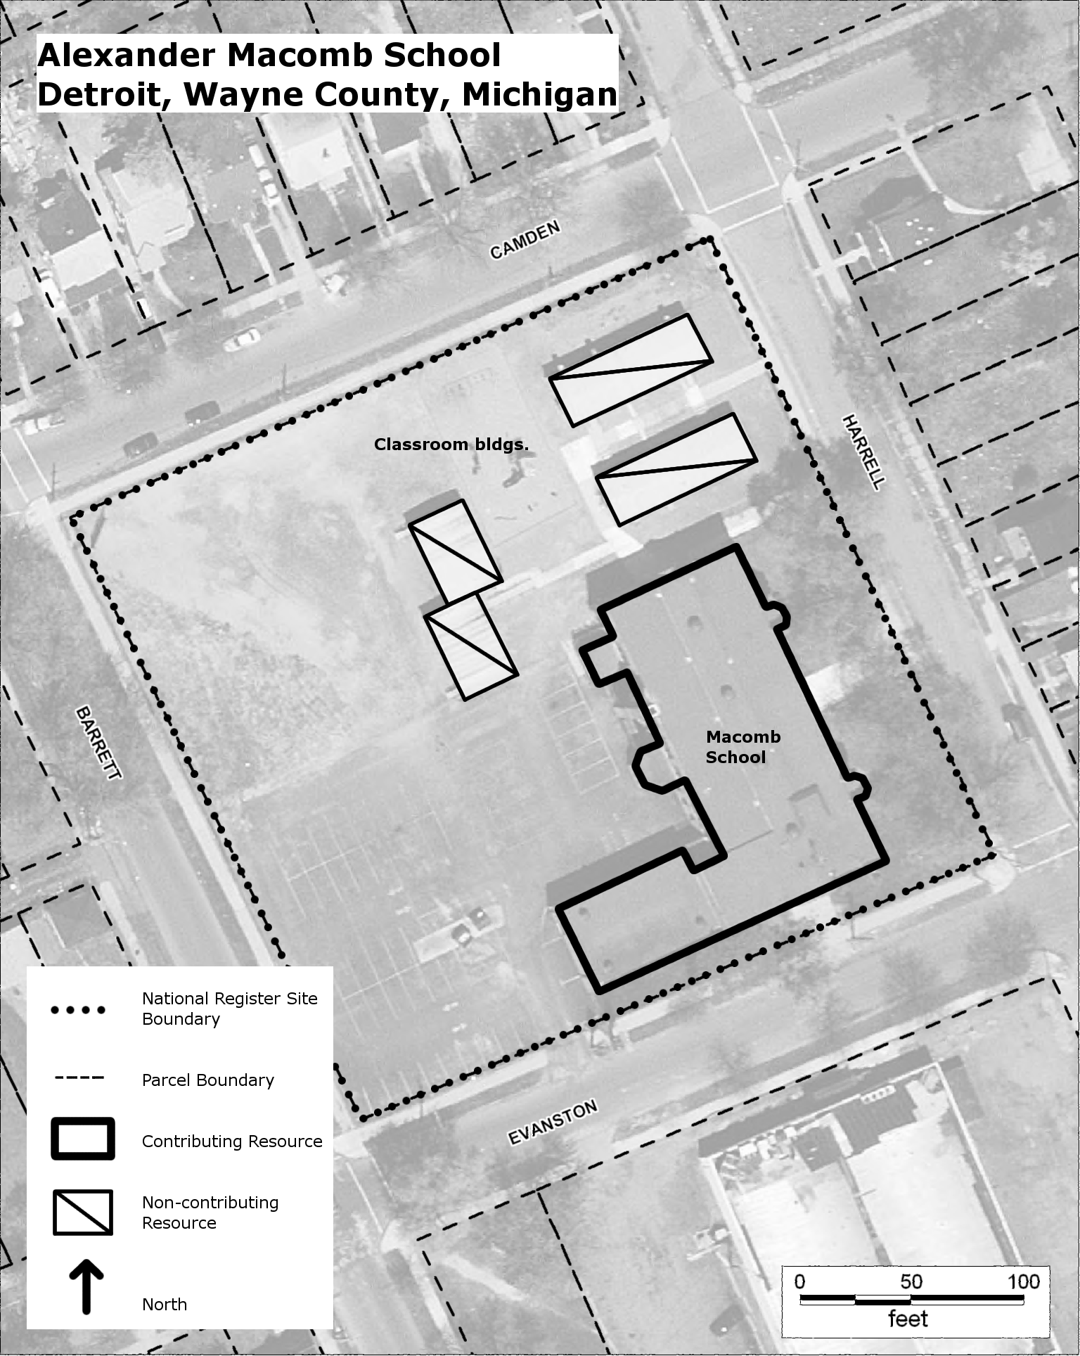

Detroit Building Safety & Engineering Department, Blueprints, Permit #51257

