United States Department of the Interior
National Park Service

National Register of Historic Places
Registration Form

This form is for use in nominating or requesting determinations for individual properties and districts. See instructions in National Register Bulletin, How to Complete the National Register of Historic Places Registration Form. If any item does not apply to the property being documented, enter "N/A" for "not applicable." For functions, architectural classification, materials, and areas of significance, enter only categories and subcategories from the instructions. Place additional certification comments, entries, and narrative items on continuation sheets (NPS Form 10-900a).

1. Name of Property
Historic name | Kosciusko, Thaddeus, School
Other names/site number |  | Kosciusko, Thaddeus, Elementary School
2. Location
street & number |  |  |  | 20220 Tireman St. |  |  |  |  |  |  |  |  |  |  | not for publication
city or town |  |  | Detroit |  |  |  |  |  |  |  |  |  |  |  | vicinity
State | Michigan |  |  |  | code | MI | county | Wayne | code | 163 | zip code |  |  |  |  | 48228
3. State/Federal Agency Certification

As the designated authority under the National Historic Preservation Act, as amended,
I hereby certify that this X nomination _ request for determination of eligibility meets the documentation standards for registering properties in the National Register of Historic Places and meets the procedural and professional requirements set forth in 36 CFR Part 60.
In my opinion, the property X meets _ does not meet the National Register Criteria. I recommend that this property be considered significant at the following level(s) of significance:
national statewide X local

____________________________________
Signature of certifying official Date

Michigan State Historic Preservation Officer ____________________ Michigan State Historic Preservation Office
Title State or Federal agency and bureau
In my opinion, the property meets does not meet the National Register criteria.

____________________________________
Signature of commenting official Date

___________________ _________
Title State or Federal agency and bureau

4. National Park Service Certification
I, hereby, certify that this property is: Signature of the Keeper Date of Action

entered in the National Register _________________________________________________________________

determined eligible for the National Register _________________________________________________________________

determined not eligible for the National Register ___________________

removed from the National Register _________

other (explain:) _________________________________________________________________

5. Classification

Ownership of Property  (Check as many boxes as apply) |  |  | Category of Property  (Check only one box) |  |  | Number of Resources within Property  (Do not include previously listed resources in the count.)
 |  |  |  |  |  | Contributing | Noncontributing
 |  | private |  | X | building(s) | 1 | 0 | buildings
 | X | public - Local |  |  | district |  |  | sites
 |  | public - State |  |  | site |  |  | structures
 |  | public - Federal |  |  | structure |  |  | Objects
 |  | private |  |  | building(s) |  |  | buildings
 |  |  |  |  | object | 1 | 0 | Total

Name of related multiple property listing  (Enter "N/A" if property is not part of a multiple property listing) |  | Number of contributing resources previously listed in the National Register

Public Schools of Detroit

6. Function or Use
Historic Functions  (Enter categories from instructions) |  | Current Functions  (Enter categories from instructions)
EDUCATION/school |  | VACANT/NOT IN USE

7. Description
Architectural Classification  (Enter categories from instructions) |  | Materials  (Enter categories from instructions)
International Style |  | foundation: |  | Concrete
 |  | walls: | Brick
 |  | roof: | Asphalt
 |  | other:

Narrative Description
(Describe the historic and current physical appearance of the property. Explain contributing and noncontributing resources if necessary. Begin with a summary paragraph that briefly describes the general characteristics of the property, such as its location, setting, size, and significant features.)

Summary Paragraph

Thaddeus Kosciusko School faces south onto Tireman Avenue between Heyden and Stout Avenues in Detroit’s Warrendale neighborhood, approximately ten miles northwest of downtown. River Rouge Park and Dearborn Township are located further west of Kosciusko School; Evergreen Road is to the east. It occupies the southern end of its block-long site; a park like grassy area with mature trees occupies the majority of the site stretching northward towards Belton Avenue. International in style, the 1955 building is a two-story, flat-roofed structure with projecting eaves and an irregular floor plan. The facade contains continuous bays of windows, now covered with security panels. Presently vacant, Kosciusko School is in good condition and retains a high degree of historic integrity.

________________________________________________________________________________________________________________________
Narrative Description

Kosciusko School is set back from the public right-of-way by an ample front yard with scattered trees and perimeter bushes. The building displays a low, horizontal appearance due to its flat roof with broad overhangs and continuous rows of windows. Its front façade is composed of three sections. A two-story section to the east of the entrance features windows stretching along its entire length. A slightly shorter, tall single story section to the west of the entrance projects outward, containing the auditorium on the interior. The entrance section, a single story projection that is flush with the auditorium section, extends eastward in front of the two-story classroom section. Wall surfaces are faced with light orange brick. All fenestration is now covered with steel security panels.

A wide concrete walkway leads to the slightly wider porch in front of the main entrance from the public sidewalk. The flat porch roof has rectangular cut-outs on each side of the entrance, and originally had light fixtures embedded in its ceiling, since replaced with ones that project. It is supported by four cast concrete pillars with visible form marks, along its front edge, and two engaged columns flanking the broad, off-centered entrance, which is composed of double doors, sidelights, and transoms, now all protected by security panels. The column at the west end of the back of the porch rises up into the corner of the auditorium section. The base of the entrance section is faced with random fieldstone; its single story was fully fenestrated. Inside the entrance is a vestibule with colorful tiled walls. Similar engaged cast concrete pillars rising from the ground to the roof divide the adjacent auditorium section and west side elevations.

According to historic photographs, the auditorium section originally had three bays of windows above a brick apron wall with a continuous concrete sill course. The upper three-quarters of the openings were filled with glass block; the lower quarter was composed of a triple window arrangement, the two outer windows with fixed panes and the center one with multiple panes. The rows of windows of the long, two-story eastern section were divided vertically into three parts. The fascia board of the front porch bore the name of the school in metal lettering.

8. Statement of Significance

Applicable National Register Criteria
(Mark "x" in one or more boxes for the criteria qualifying the property for National Register listing)
 | A |  | Property is associated with events that have made a significant contribution to the broad patterns of our history.
 | B |  | Property is associated with the lives of persons significant in our past.
X | C |  | Property embodies the distinctive characteristics  of a type, period, or method of construction or represents the work of a master, or possesses high artistic values, or represents a significant  and distinguishable entity whose components lack individual distinction.
 | D |  | Property has yielded, or is likely to yield, information important in prehistory or history.
Criteria Considerations
(Mark "x" in all the boxes that apply)
Property is:
 |  | A | owed by a religious institution or used for religious purposes.
 |  | B | removed from its original location.
 |  | C | a birthplace or grave.
 |  | D | a cemetery.
 |  | E | a reconstructed building, object, or structure.
 |  | F | a commemorative property.
 |  | G | less than 50 years old or achieving significance
 |  |  | within the past 50 years.
Areas of Significance
(Enter categories from instructions)
Architecture
Period of Significance
1955-56
Significant Dates
1955, 1956
Significant Person
N/A
Cultural Affiliation

N/A
Architect/Builder
Harley, Ellington & Day

Period of Significance (justification)

The period of significance coincides with the construction period.

Criteria Consideratons (explanation, if necessary)

Statement of Significance Summary Paragraph (provide a summary paragraph that includes level of signficance and applicable criteria)

Built in 1955, Kosciusko School represents the modern, International Style design aesthetic in a small, neighborhood pubic school. Its architects, Harley, Ellington & Day, were well known in the 1950s for such public buildings in Detroit as the City-County Building, since renamed the Coleman A. Young Municipal Center, and the Rackham Memorial Building. Kosciusko School, while substantially less elaborate and incomparable in stature, is nonetheless a good example of the kinds of buildings that the Detroit Board of Education was building up until the passage of a referendum in 1958 that allowed more funding for school construction. It is locally significant under National Register Criterion C for its architectural design.

_________________________________________________________________________________________________
Narrative Statement of Significance (provide at least one paragraph for each area of significance)

The Kosciusko School site was purchased at a cost of $51,691, and occupied by a temporary structure in 1954 as a kindergarten annex to the Dixon School. The Kosciusko School building, costing $714,026 and having a capacity of 770 students, was opened in 1956 and housed 758 students in kindergarten through the sixth grade. Sixty-five Special B students continued to use the temporary building.

Several years after the building’s construction, it was described by the Board of Education as a "beautiful community-centered building.” The northern half of the block continued to be owned by the City of Detroit and remained fully wooded. The Board of Education intended to acquire the land for use as a playfield, but these negotiations were not concluded until some time thereafter. Presently, numerous large trees remain on the site.

The architecture firm of Harley, Ellington & Day (1943-60) designed Kosciusko School. By 1941, that firm took a significant step into the public spotlight with their design for the Horace Rackham Educational Memorial Building, the third building in Detroit’s cultural center. It was later responsible for the south and north additions to the Detroit Institute of Arts. It designed other notable Detroit civic structures, including the City-County Building (1955). The firm continues as Harley Ellis Devereau today.

________________________________________________________________________________________________________________________
Developmental history/additional historic context information (if appropriate)

9. Major Bibliographical References

Bibliography (Cite the books, articles, and other sources used in preparing this form on one or more continuation sheets)

Previous documentation on file (NPS): |  | Primary location of additional data:
 | preliminary determination of individual listing (36 CFR 67 has been |  |  | State Historic Preservation Office
 | requested |  |  | Other State agency
 | previously listed in the National Register |  |  | Federal agency
 | previously determined eligible by the National Register |  |  | Local government
 | designated a National Historic Landmark |  |  | University
 | recorded by Historic American Buildings Survey #____________ |  |  | Other
 | recorded by Historic American Engineering Record # ____________ |  | Name of repository:

Historic Resources Survey Number (if assigned): _____________________________________________________________________
10. Geographical Data

Acreage of Property | 3.7
(Do not include previously listed resource acreage)

UTM References
(Place additional UTM references on a continuation sheet)

1 | 17 |  | 315602 |  | 4691129 |  |  | 3
 | Zone |  | Easting |  | Northing |  |  |  | Zone |  | Easting |  | Northing
2 |  |  |  |  |  |  |  | 4
 | Zone |  | Easting |  | Northing |  |  |  | Zone |  | Easting |  | Northing

Verbal Boundary Description (describe the boundaries of the property)

The boundaries of this site include the following two parcels:

N TIREMAN PT OF N E 1/4 SEC 3 T 2 S R 10 E DESC AS FOLS BEG AT A PTE IN E LINE OF STOUT AVE 60 FT WD 303 FT NLY ALG SD LINE FROM E W 1/4 LINE TH N 1D 45M W 330.61 FT TH N 88D 41M 20S E 272.15 FT ALG S LINE OF BELTON AVE TH S 1D 46M 20S E 330.74 FT ALG W LINE OF HEYDEN AVE TH S 88D 43M W 272.28 FT TO P O B 22/--- 2.066 AC

and

N TIREMAN PT OF N E 1/4 SEC 3 T 2 S R 10 E DESC AS FOLS BEG AT A PTE IN N LINE OF TIREMAN AVE 43 FT NLY OF E W 1/4 LINE SD PTE BG ALSO IN E LINE OF STOUT AVE 60 FT WD TH N 1D 45M W 260 FT TH N 88D 43M E 272.28 FT TH S 1D 46M 20S E 150 FT ALG W LINE OF HEYDEN AVE TH N 88D 43M E 3 FT TH S 1D 46M 20S E 110 FT TH S 88D 43M W 275.38 FT TO P O B 22/--- 1.633 AC

Boundary Justification (explain why the boundaries were selected)

The boundaries described above include the entire site historically associated with Kosciusko School.

11. Form Prepared By
name/title | Deborah M. Goldstein
organization |  |  | City of Detroit Historic Designation Advisory Board |  | date | March 25, 2009
street & number |  |  |  | CAYMC, 2 Woodward Avenue, Suite 204 | telephone |  |  | (313) 224-3487
city or town |  | Detroit |  |  | state |  | MI |  | zip code | 48226
e-mail |  | cc-historic@detroitmi.gov

Additional Documentation
Submit the following items with the completed form:

- Maps: A USGS map (7.5 or 15 minute series) indicating the property's location.

A Sketch map for historic districts and properties having large acreage or numerous resources. Key all photographs to this map.

- Continuation Sheets

- Additional items: (Check with the SHPO or FPO for any additional items)

Photographs:
Submit clear and descriptive black and white photographs. The size of each image must be 1600x1200 pixels at 300 ppi (pixels per inch) or larger. Key all photographs to the sketch map.

See continuation sheet.

Paperwork Reduction Act Statement: This information is being collected for applications to the National Register of Historic Places to nominate properties for listing or determine eligibility for listing, to list properties, and to amend existing listings. Response to this request is required to obtain a benefit in accordance with the National Historic Preservation Act, as amended (16 U.S.C.460 et seq.).
Estimated Burden Statement: Public reporting burden for this form is estimated to average 18 hours per response including time for reviewing instructions, gathering and maintaining data, and completing and reviewing the form. Direct comments regarding this burden estimate or any aspect of this form to the Chief, Administrative Services Division, National Park Service, PO Box 37127, Washington, DC 20013-7127; and the Office of Management and Budget, Paperwork Reductions Project (1024-0018), Washington, DC 20503.

United States Department of the Interior
National Park Service

National Register of Historic Places Continuation Sheet

Section number 9 | Page 1
_________________________________________________________________________________________________________________________

Bibliography

Detroit, City of, Board of Education. Histories of the Public Schools of Detroit. Detroit: Board of Education, 1967.

WSU Virtual Motor City Collection (Detroit News) Record #70333_1

Sanborn Map Company. Detroit, Mich. Vol. 29, Sheet 39. Pelham, NY: Sanborn Map Company, 2003.

United States Department of the Interior
National Park Service

National Register of Historic Places Continuation Sheet

Section number 10 | Page 1
_________________________________________________________________________________________________________________________

Photographs

Photographer: Timothy Boscarino
Date: November 2008
Paper and Ink: HP Premium Plus Glossy Photo Paper, HP Vivera Ink

- South elevation.
(MI_Wayne_KosciuskoSch0001.tif)

- South and west elevations.
(MI_Wayne_KosciuskoSch0002.tif)

- South and east elevations.
(MI_Wayne_KosciuskoSch0003.tif)

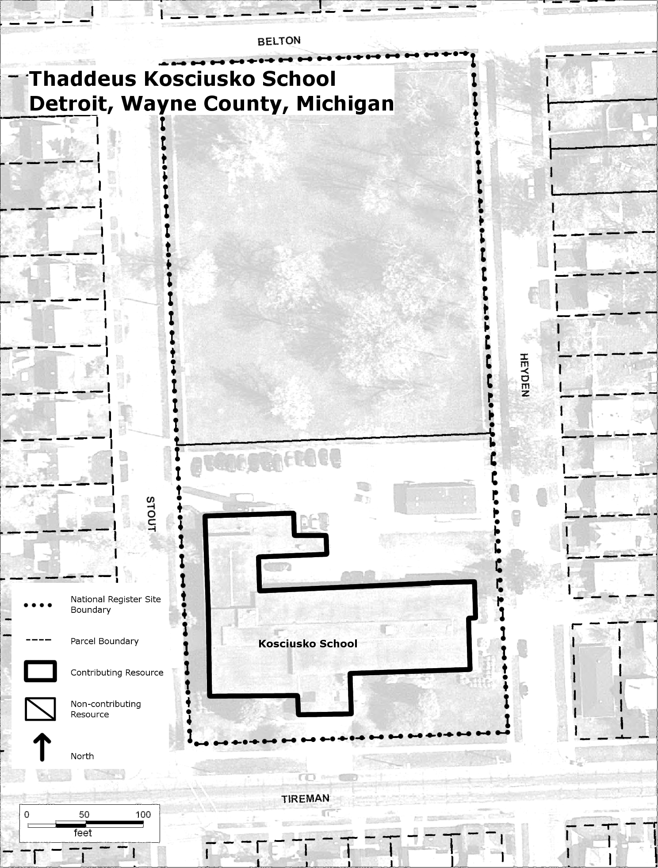

Detroit, City of, Board of Education, Histories of the Public Schools of Detroit, 1967, vol. 2, p. 683.
Ibid.

