United States Department of the Interior
National Park Service

National Register of Historic Places
Registration Form

This form is for use in nominating or requesting determinations for individual properties and districts. See instructions in National Register Bulletin, How to Complete the National Register of Historic Places Registration Form. If any item does not apply to the property being documented, enter "N/A" for "not applicable." For functions, architectural classification, materials, and areas of significance, enter only categories and subcategories from the instructions. Place additional certification comments, entries, and narrative items on continuation sheets (NPS Form 10-900a).

1. Name of Property
Historic name | Parkman, Francis, School
Other names/site number |  | Parkman, Francis, Elementary School
2. Location
street & number |  |  |  | 15000 MacKenzie St. |  |  |  |  |  |  |  |  |  |  | not for publication
city or town |  |  | Detroit |  |  |  |  |  |  |  |  |  |  |  | vicinity
State | Michigan |  |  |  | code | MI | county | Wayne | code | 163 | zip code |  |  |  |  | 48228
3. State/Federal Agency Certification

As the designated authority under the National Historic Preservation Act, as amended,
I hereby certify that this X nomination _ request for determination of eligibility meets the documentation standards for registering properties in the National Register of Historic Places and meets the procedural and professional requirements set forth in 36 CFR Part 60.
In my opinion, the property X meets _ does not meet the National Register Criteria. I recommend that this property be considered significant at the following level(s) of significance:
national statewide X local

____________________________________
Signature of certifying official Date

Michigan State Historic Preservation Officer _________________ ___ Michigan State Historic Preservation Office
Title State or Federal agency and bureau
In my opinion, the property meets does not meet the National Register criteria.

____________________________________
Signature of commenting official Date

___________________ _________
Title State or Federal agency and bureau

4. National Park Service Certification
I, hereby, certify that this property is: Signature of the Keeper Date of Action

entered in the National Register _________________________________________________________________

determined eligible for the National Register _________________________________________________________________

determined not eligible for the National Register ___________________

removed from the National Register _________

other (explain:) _________________________________________________________________

5. Classification

Ownership of Property  (Check as many boxes as apply) |  |  | Category of Property  (Check only one box) |  |  | Number of Resources within Property  (Do not include previously listed resources in the count.)
 |  |  |  |  |  | Contributing | Noncontributing
 |  | private |  | X | building(s) | 2 |  | buildings
 | X | public - Local |  |  | district |  |  | sites
 |  | public - State |  |  | site |  |  | structures
 |  | public - Federal |  |  | structure |  |  | Objects
 |  | private |  |  | building(s) |  |  | buildings
 |  |  |  |  | object | 2 | 0 | Total

Name of related multiple property listing  (Enter "N/A" if property is not part of a multiple property listing) |  | Number of contributing resources previously listed in the National Register

Public Schools of Detroit

6. Function or Use
Historic Functions  (Enter categories from instructions) |  | Current Functions  (Enter categories from instructions)
EDUCATION/school |  | VACANT/NOT IN USE

7. Description
Architectural Classification  (Enter categories from instructions) |  | Materials  (Enter categories from instructions)
Moderne |  | foundation: |  | Concrete
 |  | walls: | Brick
 |  |  | Stone: Limestone
 |  | roof: | Asphalt
 |  | other:

Narrative Description
(Describe the historic and current physical appearance of the property. Explain contributing and noncontributing resources if necessary. Begin with a summary paragraph that briefly describes the general characteristics of the property, such as its location, setting, size, and significant features.)

Summary Paragraph

Francis Parkman School occupies nearly all of a city block, southwest of the intersection of Joy Road and Greenfield Road on the city’s west side. The site is bounded by Robson Street on the east, MacKenzie Street on the south, Coyle Street to the west, and a pair of buildings fronting on Joy Road to the north. The building occupies a U-shaped footprint on the southern third of its parcel; a large playfield is located to the north. The building is a Moderne-style, two-story, flat-roofed brick structure. Also located on the site is a freestanding boiler house. The buildings, although presently vacant, appear to be in good condition and retain a high degree of historic integrity.

________________________________________________________________________________________________________________________
Narrative Description

The northern two-thirds of the Parkman School site consist of a grassy playfield. The school building is located on the southern third of this block, facing south, about sixty feet from MacKenzie Street. Several mid-sized trees occupy the front lawn, which is enclosed behind a short chain-link fence. Behind the school building is a boiler house and parking lot.

The first unit of Parkman School was completed in 1941. It was expanded from its initial, western, wing in 1948 and 1954 to create an overall U-plan, opening south onto MacKenzie Street. This is a two-story, flat-roofed structure, with rounded corners on all elevations, in the Moderne style. The U-shaped building is somewhat asymmetrical, as its eastern wing extends closer to the street than its western wing. A pair of front entrances exists, one centered on each of the building’s wings. Side entrances exist on the east and west elevations.

The building’s four entrances are identical. A rounded projection houses each entryway, extending from the ground level up to conclude in a parapet wall about a foot above the building’s roofline. Double doors are recessed into a stone surround, curving inward to accommodate the doorway. Each surround is simply decorated with a series of horizontal lines and the words “FRANCIS PARKMAN SCHOOL” above. Above this, three ribbon window openings extend vertically to the top of the second floor. The bottom of each window opening features a stone panel with a raised, geometric design of several concentric rectangles. Above the second story is a stone panel with a simple geometric design of three diamonds.

The building’s walls are clad in common-bond brickwork, with bricks in varying shades of brown and reddish-brown. Stone sill and lintel courses extend from evenly-spaced, square windows. The topmost course extends around the entirety of the building; the remaining three courses are interrupted by the building’s entrance projections. Every eighth course of brickwork is a raised header course, extending around the building and adding a horizontal emphasis to the structure. These raised courses are interrupted (instead becoming flush with the wall surface for several feet) to either side of the building’s main entrances, aesthetically suggesting window openings where none exist. A slight parapet with stone coping runs around the building. The building’s windows and doors have been boarded and are not visible. A conservatory projects from the inside of the building’s eastern wing; this also has been covered in boards.

The building’s boiler house occupies a square-shaped footprint. Its small window and door openings are unadorned. Its brown, common-bond brickwork matches that of the main building, but without the raised header courses. A stone belt course wraps around the building about seven feet from the ground. A brick, squared smokestack extends upward, tapering with a series of two slight setbacks.
8. Statement of Significance

Applicable National Register Criteria
(Mark "x" in one or more boxes for the criteria qualifying the property for National Register listing)
 | A |  | Property is associated with events that have made a significant contribution to the broad patterns of our history.
 | B |  | Property is associated with the lives of persons significant in our past.
X | C |  | Property embodies the distinctive characteristics  of a type, period, or method of construction or represents the work of a master, or possesses high artistic values, or represents a significant  and distinguishable entity whose components lack individual distinction.
 | D |  | Property has yielded, or is likely to yield, information important in prehistory or history.
Criteria Considerations
(Mark "x" in all the boxes that apply)
Property is:
 |  | A | owned by a religious institution or used for religious purposes.
 |  | B | removed from its original location.
 |  | C | a birthplace or grave.
 |  | D | a cemetery.
 |  | E | a reconstructed building, object, or structure.
 |  | F | a commemorative property.
 |  | G | less than 50 years old or achieving significance
 |  |  | within the past 50 years.
Areas of Significance
(Enter categories from instructions)
Architecture
Period of Significance
1940-1954
Significant Dates
1941, 1948, 1954
Significant Person
N/A
Cultural Affiliation

N/A
Architect/Builder
Detroit Board of Education
Charles J. Sullivan

Period of Significance (justification)

The Period of Significance extends from the start of construction to the completion of the building’s final unit.

Criteria Considerations (explanation, if necessary)

Statement of Significance Summary Paragraph (provide a summary paragraph that includes level of signficance and applicable criteria)

Francis Parkman School is locally significant under National Register Criterion C as the City of Detroit’s earliest use of the Moderne style in school building construction. Parkman School is unique among Detroit schools in that it was designed neither by a third-party architect on a contractual basis, nor from the plans of an already-existing school building. Likely as a cost-saving measure, the Detroit Board of Education directed its own Department of Buildings and Grounds staff to devise architectural drawings for the building.

________________________________________________________________________________________________________________________
Narrative Statement of Significance (provide at least one paragraph for each area of significance)

This school was named after the American historian Francis Parkman (1823-1893). It opened in 1930 in a temporary, portable classroom building located on the present site, and another was added the following year. The first unit of the permanent building, consisting of three classrooms, was completed in 1941. The temporary buildings continued to exist for some time thereafter.

By 1947 the school became quite crowded, with 359 students. To accommodate this growth, a second unit, consisting of seven classrooms and a gymnasium, was added in 1948. Charles J. Sullivan served as supervising architect for this addition. A third unit was constructed in 1954 at a cost of $494,506. It added an auditorium and eleven classrooms, including two science rooms. At this time the school was organized into eighteen sections, with one self-contained class. In 1960 the school was reorganized into fourteen sections with four self-contained rooms.

An entry in the Proceedings of the Board of Education provides a list of supervising architects for all Detroit schools scheduled to be constructed during the 1940-1941 school year. Alfred A. Smith was identified as the contractor for the architectural work. The plans for this building may have been devised by the staff of the Board of Education’s Department of Buildings and Grounds with Smith supervising the work. The name on the blueprints for construction of the building was O’Brien & Williamson Metal Products Company.

From the turn of the nineteenth century, school building design in the region was wholly dominated by classical and historical revival styles. More forward-looking, yet still ornate, Art Deco designs began to appear around 1928. Parkman School, however, marked a sharp break from both of these traditions. With its use of the Streamline Moderne style, Parkman School, with its crisp lines, graceful curves, and minimum of exterior ornamentation, set the stage for the widespread building of International Style school buildings in the postwar years.

________________________________________________________________________________________________________________________
Developmental history/additional historic context information (if appropriate)

9. Major Bibliographical References

Bibliography (Cite the books, articles, and other sources used in preparing this form on one or more continuation sheets)

Previous documentation on file (NPS): |  | Primary location of additional data:
 | preliminary determination of individual listing (36 CFR 67 has been |  |  | State Historic Preservation Office
 | requested |  |  | Other State agency
 | previously listed in the National Register |  |  | Federal agency
 | previously determined eligible by the National Register |  |  | Local government
 | designated a National Historic Landmark |  |  | University
 | recorded by Historic American Buildings Survey #____________ |  |  | Other
 | recorded by Historic American Engineering Record # ____________ |  | Name of repository:

Historic Resources Survey Number (if assigned): _____________________________________________________________________
10. Geographical Data

Acreage of Property | 4
(Do not include previously listed resource acreage)

UTM References
(Place additional UTM references on a continuation sheet)

1 | 17 |  | 319457 |  | 4691640 |  |  | 3
 | Zone |  | Easting |  | Northing |  |  |  | Zone |  | Easting |  | Northing
2 |  |  |  |  |  |  |  | 4
 | Zone |  | Easting |  | Northing |  |  |  | Zone |  | Easting |  | Northing

Verbal Boundary Description (describe the boundaries of the property)

E COYLE 1148 THRU 1131 S 31 FT 1130 FRISCHKORNS W CHICAGO BLVD SUB L46 P11-2 PLATS, W C R 22/540 6 THRU 24 & VAC ALLEY ADJ OBENAUER-BARBER-LAING ORCHARD BLVD L46 P90 PLATS, W C R 22/54

Boundary Justification (explain why the boundaries were selected)

The boundaries described above include the entire parcel historically associated with Parkman School.

11. Form Prepared By
name/title | Timothy Boscarino
organization |  |  | City of Detroit Historic Designation Advisory Board |  | date | May 13, 2009
street & number |  |  |  | CAYMC, 2 Woodward Avenue, Suite 204 | telephone |  |  | (313) 224-3487
city or town |  | Detroit |  |  | state |  | MI |  | zip code | 48226
e-mail |  | cc-historic@detroitmi.gov

Additional Documentation
Submit the following items with the completed form:

- Maps: A USGS map (7.5 or 15 minute series) indicating the property's location.

A Sketch map for historic districts and properties having large acreage or numerous resources. Key all photographs to this map.

- Continuation Sheets

- Additional items: (Check with the SHPO or FPO for any additional items)

Photographs:
Submit clear and descriptive black and white photographs. The size of each image must be 1600x1200 pixels at 300 ppi (pixels per inch) or larger. Key all photographs to the sketch map.

See continuation sheet.

Paperwork Reduction Act Statement: This information is being collected for applications to the National Register of Historic Places to nominate properties for listing or determine eligibility for listing, to list properties, and to amend existing listings. Response to this request is required to obtain a benefit in accordance with the National Historic Preservation Act, as amended (16 U.S.C.460 et seq.).
Estimated Burden Statement: Public reporting burden for this form is estimated to average 18 hours per response including time for reviewing instructions, gathering and maintaining data, and completing and reviewing the form. Direct comments regarding this burden estimate or any aspect of this form to the Chief, Administrative Services Division, National Park Service, PO Box 37127, Washington, DC 20013-7127; and the Office of Management and Budget, Paperwork Reductions Project (1024-0018), Washington, DC 20503.

United States Department of the Interior
National Park Service

National Register of Historic Places Continuation Sheet

Section number 9 | Page 1
_________________________________________________________________________________________________________________________

Bibliography

Detroit, City of, Board of Education. Histories of the Public Schools of Detroit. Detroit: Board of Education, 1967.

Detroit, City of, Buildings and Safety Engineering Department. Building Permit Card Index. Permit #39466, June 19, 1940; Permit #35367, November 1, 1946; Permit #542, January 19, 1953

Detroit, City of, Building Safety & Engineering, Blueprints.

Sanborn Map Company. Detroit, Mich. Vol. 17, Sheet 95. Pelham, NY: Sanborn Map Company, 2003.

United States Department of the Interior
National Park Service

National Register of Historic Places Continuation Sheet

Section number 10 | Page 1
_________________________________________________________________________________________________________________________

Photographs

Photographer: Timothy Boscarino
Date: December 2008
Paper and Ink: HP Premium Plus Glossy Photo Paper, HP Vivera Ink

- South and west elevations.
(MI_Wayne_ParkmanSch0001.tif)

- West entrance on south elevation.
(MI_Wayne_ParkmanSch0002.tif)

- West and south elevations of boiler house.
(MI_Wayne_ParkmanSch0003.tif)

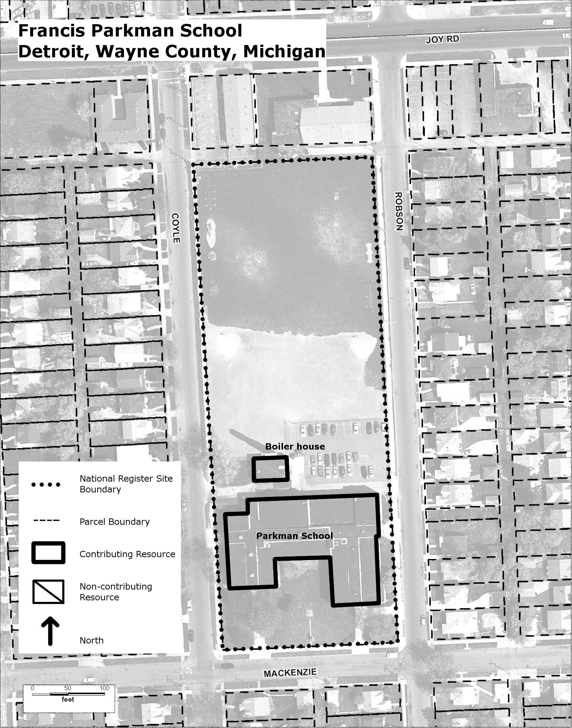

Detroit Board of Education 1940, 406.
Detroit Buildings and Safety Engineering Department. Blueprints, Permit #39466, 1940.

